Suppl 9. A single glutamine to leucine mutation at residue 226 of the virus hemagglutinin was sufficient to enact the change from avian to human specificity.
(A) The three dimensional structure of Texas H5 HA was determined at 2.80-Å resolution. One HA monomer is highlighted in gray for 220-loop. The receptor binding site is composed of the 220-loop. Key residues and additional mutations analyzed in this study are shown as red and lavender dots, respectively. (B) Sequence comparison of 220-loop of WT Texas with human pandemic H1, H2, and H3 HA and human-infecting H5N1 HA. The hallmark residues for switch of receptor binding preference in 220-loop are highlighted in red. For HA-receptor analogs complexes, we used LSTa (Neu5Acα2-3Galβ1-3GlcNAcβ1-3Galβ1-4Glc), and LSTc (Neu5Acα2-6Galβ1-3GlcNAcβ1 3Galβ1-4Glc).
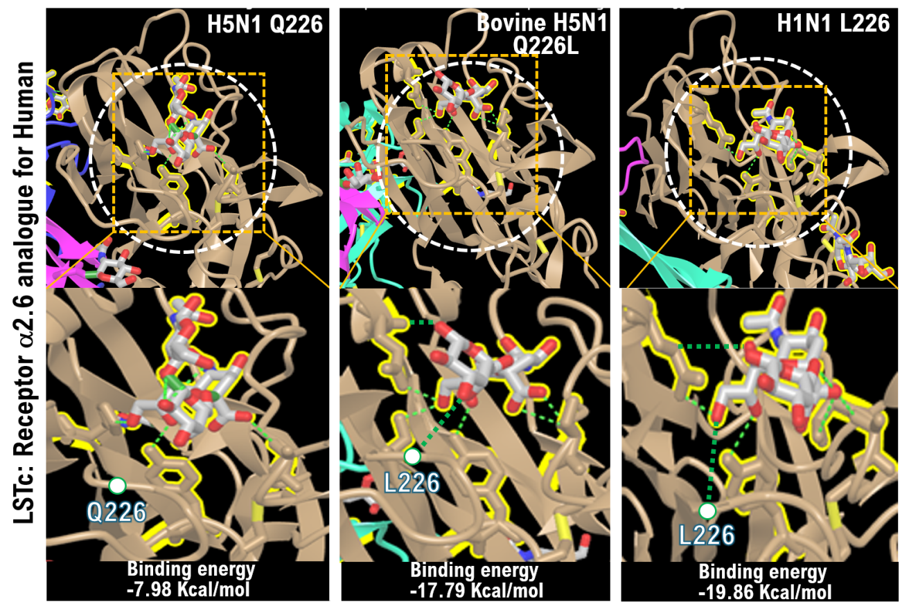
(A)
(B)

 | 220-loop |  |  |  |  |  |  |  | Binging efficiency with α2.6SA
Strain | 221 | 222 | 223 | 224 | 225 | 226 | 227 | 228
A/Texas/37/2024 H5N1 | S | Q | V | N | G | Q | R | G | NO
Bovine-A/Texas/37/2024 H5N1 | S | Q | V | N | G | L | R | G | Strong
A/California/06/2009/H1N1 | S | Q | V | R | G | L | R | G | Strong

