Suppl 3. Construction of the three-dimensional complex structure of the loop region of HA docked with the three-dimensional structure of LSTa/LSTc.

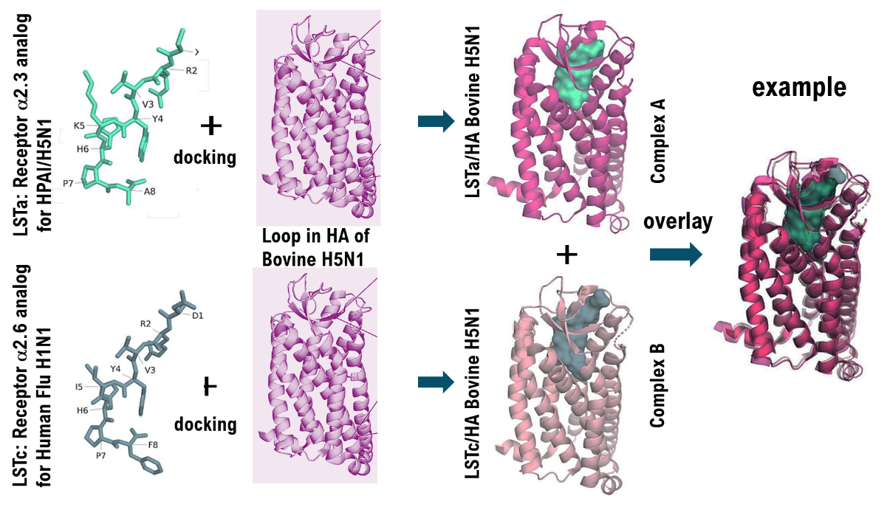

The loop region of Bovine H5N1 HA binds to the host receptor α2.3SA. Therefore, we constructed the three-dimensional structure of the loop region of Bovine H5N1 HA. Next, we construct the three-dimensional structure of LSTa, an analog of α2.3SA. The three-dimensional structure of the loop region of Bovine H5N1 HA is docked with the three-dimensional structure of LSTa to create the complex structure. The three-dimensional structure of this complex is called basic three-dimensional structure (Complex A).

We construct the three-dimensional structure of the loop region of Bovine H5N1 HA. Next, we construct the three-dimensional structure of LSTc, an analog of α2.6SA. The three-dimensional structure of the loop region of Bovine H5N1 HA and the three-dimensional structure of LSTc are combined to create the complex structure. The three-dimensional structure of this complex is designated as the target three-dimensional structure (Complex B).

The corresponding three-dimensional structure (Complex B) is superimposed on the basic three-dimensional structure (Complex A). On the other hand, if the basic three-dimensional structure (Complex A) and the target three-dimensional structure (Complex B) do not match, the loop region of the HA of Bovine H5N1 is considered not to bind to the host receptor α2.6SA. The results of this study suggest that Bovine H5N1 binds to the host receptor α2.6SA for human influenza viruses.

